O'ZBEKISTON RESPUBLIKASI HARBIY XAVFSIZLIK VA MUDOFAA UNIVERSITETINING AXBOROT-KOMMUNIKATSIYA TEXNOLOGIYALARI VA HARBIY ALOQA INSTITUTI

“Sun‘iy intellekt asoslari” fanidan
4-MUSTAQIL ISH

Bajardi Kursant : Bahriddinov B.
Qabul qildi: k-n Isakov M.

- VARIANT: Ob-havo va Ekologiya tahlili
Bu variantda harorat, namlik va havo sifati kabi tabiat ma’lumotlari bilan ishlaysiz.
- Savol(NumPy): Harorat statistikasi
Vazifa:
Shaharning 10 kunlik havo harorati berilgan: [22, 25, 28, 30, 26, 24, 29, 31, 27, 23].
- Massiv yarating.
2) Maksimal va minimal haroratni toping.
3) Harorat 25 gradusdan yuqori bo'lgan kunlar sonini hisoblang.
Dastur kodi:
import numpy as np
temperatures = np.array([22, 25, 28, 30, 26, 24, 29, 31, 27, 23])
max_temp = np.max(temperatures)
min_temp = np.min(temperatures)
days_above_25 = np.sum(temperatures > 25)
print("Haroratlar:", temperatures)
print("Maksimal harorat:", max_temp)
print("Minimal harorat:", min_temp)
print("25°C dan yuqori bo'lgan kunlar soni:", days_above_25)
Natija:
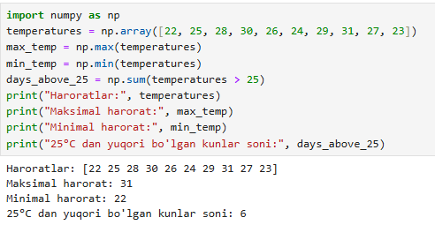
- Savol(Pandas): Ma’lumotlarni tozalash
Vazifa:
Ob-havo stansiyasidan olingan ma’lumotlarda bazi xatoliklar (NaN) bor:
- Kun: 1, 2, 3, 4
- Harorat: 20, NaN, 25, 22
- Namlik: 40, 45, NaN, 50
- DataFrame yarating.
- NaN qiymatlarni ustunning o’rtacha qiymati (mean) bilan to’ldiring.
- Tozalangan jadvalni ekranga chiqarib bering.
Dastur kodi:
import pandas as pd
data = {
"Kun": [1, 2, 3, 4],
"Harorat": [20, np.nan, 25, 22],
"Namlik": [40, 45, np.nan, 50]
}
df = pd.DataFrame(data)
print("Boshlang'ich jadval:")
print(df)
df_filled = df.fillna(df.mean(numeric_only=True))
print("\nTozalangan jadval:")
print(df_filled)
Natija:
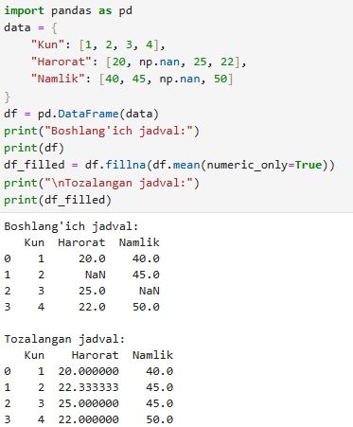
- Savol(Matplotlib): Ikki shahar taqqoslashi
Vazifa:
Toshkent va Samarqand shaharlarining 5 kunlik harorati berilgan.
Toshkent: [25, 28, 30, 27, 26]
Samarqand: [22, 26, 28, 25, 24]
Ikkala shaharning harorat o’zgarishini bitta grafikda chiziqli(line plot) ko’rinishida tasvirlang. Har bir chiziqqa alohida rang va legend bering.
Dastur kodi:
import matplotlib.pyplot as plt
days = [1, 2, 3, 4, 5]
toshkent = [25, 28, 30, 27, 26]
samarqand = [22, 26, 28, 25, 24]
plt.plot(days, toshkent, color='red', marker='o', label='Toshkent')
plt.plot(days, samarqand, color='blue', marker='s', label='Samarqand')
plt.title("Toshkent va Samarqand harorat taqqoslanishi")
plt.xlabel("Kunlar")
plt.ylabel("Harorat (°C)")
plt.legend()
plt.grid(True)
plt.show()
Natija:
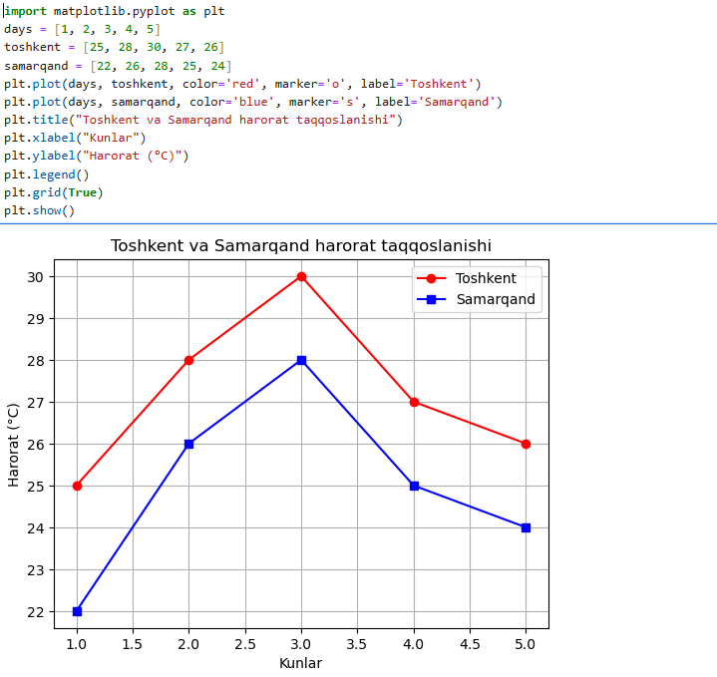

- Savol(Seaborn): Korrelyatsiya(Heatmap)
Vazifa:
Ob-havo parametrlarining o’zaro bog’liqligini ko’rish kerak.
Harorat, namlik, shamaol_tezligi ustunlaridan iborat DataFrame yarating(ixtiyoriy 5 ta qator).
Df.corr() funksiyasi orqali korrelyatsiya matritsasini oling va uni seaborn yordamida Heatmap(issiqlik xaritasi) ko’rinishida chizing.

Dastur kodi:
import pandas as pd
import seaborn as sns
import matplotlib.pyplot as plt
data = {
"Harorat": [22, 25, 28, 30, 27],
"Namlik": [60, 55, 50, 45, 48],
"Shamol_tezligi": [3, 4, 5, 6, 4]
}
df = pd.DataFrame(data)
corr_matrix = df.corr()
plt.figure(figsize=(6, 4))
sns.heatmap(
corr_matrix,
annot=True,
cmap="coolwarm",
fmt=".2f"
)
plt.title("Ob-havo parametrlarining korrelyatsiyasi")
plt.show()

Natija:
